Business Intelligence in Healthcare - Personal Project

ISMG 6810 Fall 2017

Name: Health Prime Business Intelligence Dashboard



Student Name: Sindhuja Ramineni

Student ID: 108674023

Table of Contents

Road Map 3

Executive Summary 4

Description of Organization 5

Process Description 5

Sandstone’s Existing Workflow Process 6

Deployment of Process Improvement through Dashboards 6

Mitigation of Deployment Risks 7

Change Management for Your Process Improvement 8

Dashboard Usability and Effectiveness 9

Resources 12

**Road Map**

The roadmap for our project proposal includes goals like assignments, collecting data, making dashboards, analyzing and making good decision results. Our roadmap consists of dates and objectives that we will be accomplishing. Using the rubric provided, we divided the project into equal parts and worked independently to accomplish our assigned portions; some tasks were assigned to individuals and others were assigned to all members of the group. Every individual was responsible for quality control and quality analysis of the overall document.

# **Executive Summary**

Health Prime is a Business Intelligence (BI) solutions company that focuses on the healthcare industry to deliver quality technology solutions for our clients with the ultimate goal of improving patient health. Heath Prime’s BI solutions can help Sandstone Care improve on their performance and patient outcomes by utilizing data tracking, analysis of the drastic conditions people are facing due to the usage of opioids in excessive amounts, visualization of the effects people are facing with respect to gender, age etc. This is accomplished by consolidating your data sets and setting up key performance indicator dashboards, which we will preview for you later. By utilizing these dashboards, physicians can easily make quick decisions on which method can be adopted for the fast recovery of their patients within a very short time. There is a small hope that the dashboards that you will ultimately use within your organization will bring insight into opioid usage and treatment effectiveness. The software that we have customized for you is Tableau, due to its ease of accessibility, enhanced visibility, ease of use, help documentation, etc. It is a user friendly software in which by keeping the data it gives the results in an effective and efficient manner. No coding as such is required in order to generate the results. Health Prime strives to determine which treatment options are most effective or start to help substance abuse clinics with establishing benchmarks on which they can track the effectiveness of their treatment options. When you implement your BI solutions, we are confident that it will improve your internal processes, make you more efficient, and begin to see patterns in patient treatment options, which could lead to more clinical trials. The data that we present to you here is from a variety of sources and is just a snapshot of the capabilities of Tableau. Ultimately you will drive what the dashboards depict based on what is most important to your business objectives. Feel free to use these dashboard examples as a platform for your physicians to hopefully better care for their patients. Tableau helps in clear predictions and analysis. We feel it is the best choice for your current process in order to get to the next level of BI in your organization.

Client: Sandstone Care, Denver, CO

<https://www.sandstonecare.com/>

# **Description of Organization**

Sandstone Care is a treatment center in Denver and Boulder, Colorado for young adults and adolescents struggling with substance abuse and mental health disorders. They claim to be an “evidence-based, integrated” treatment center who tailors their treatment program to the individual. They focus on a holistic approach that looks at both the individual and their environment. They offer programs like extended care treatment, day treatment, intensive outpatient program and aftercare outpatient program. All these programs extend for a specific period of time so that sustainable lasting recovery is ensured. Health Prime will provide a program that utilizes business intelligence, prescriptive analytics and the use of dashboards to improve on their current treatment strategies.

**Process Description**

Health Prime chose drug abuse, and more specifically opioid abuse, because it is one of the biggest challenges facing the United States currently. Generally opioids are prescribed by physicians to relieve excessive pain. But over the long run it reduces the pain-relieving effects and pain becomes even worse. Its dependence causes withdrawal symptoms and addiction prevails in the user’s daily life. Analysts say that it affects mostly the 19-40 age group. Symptoms of addiction include analgesia, sedation, euphoria, nausea, etc. People can’t control the usage of opioids though they know it has adverse impacts on family relationships, finances, and work structure and more adversely on their health conditions. A report by the Substance Abuse and Mental Health Services Administration Center for Behavioral Health Statistics and Quality, dated September 8, 2016 estimates that over 2 million people within the US have a problem with opioids. Of the 20.5 million Americans 12 or older that had a substance use disorder in 2015, 2 million had a substance use disorder involving prescription pain relievers and 591,000 had a substance use disorder involving heroin. It is estimated that 23% of individuals who use heroin develop opioid addiction.

Age and gender may play a big role into the amount of opioid usage. For instance, women are more likely to have chronic pain, be prescribed prescription pain relievers, be given higher doses, and use them for longer time periods than men. Women may become dependent on prescription pain relievers more quickly than men. Analysis says that 48,000 women died of prescription pain reliever overdoses from 1999 to 2010.

Keeping all these factors into consideration, health prime strives to determine which treatment options are most effective or start to help substance abuse clinics with establishing benchmarks on which they can track the effectiveness of their treatment options.

We begin this proposal by outlining our understanding of Sandstone’s current workflow process and then we’ll go into our recommendations on how to best implement Business Intelligence solutions to improve your current processes.

# **Sandstone’s Existing Workflow Process**

Currently, Sandstone’s process involves each of the various groups within the treatment center working in silos and not sharing information amongst the groups efficiently. Physicians make handwritten notes about their patient’s behaviors, treatment responses, etc. in paper notepads. Sometimes this information is uploaded to the center’s Access database, but in most cases the physicians are not encouraged to keep the database up to date. A couple of the physicians use their own excel spreadsheets to keep track of their data and run their own reports. The center has one IT technician on staff that troubleshoots software and hardware problems, manages supplies such as ordering print cartridges and is responsible for entering information into the Access database when the physicians give him their handwritten notes.

Sandstone plans on opening up another clinic in Southeast Denver and they would like the new office to tie seamlessly with their current office for sharing data.

**Deployment of Process Improvement through Dashboards**

We recommend that Sandstone implement a data warehouse and utilize Extract, Transform and Load (ETL) processes to pull information from their various data sources (Access, Excel, notes, etc.) into the data warehouse. This could be done utilizing Sandstone’s existing IT staff or outsourced to an outside vendor such as Health Prime to implement the hardware and software solutions for you.

We recommend that the center purchase an EHR system for their patients so that physicians can input information about their patients directly into the database system. We recommend that physicians phase out the usage of paper records or at a minimum have the information entered into the EHR at the end of each work day.

Once the EHR and data warehouse are established, our business intelligence solution proposes the use of dashboards. Dashboards are a snapshot of your key performance indicators brought to you in one easy visualization. Anyone in the business structure from nurses to physicians to clerical staff to executives will be able to access the dashboard, which can be tailored to their specific group objectives. Dashboards make data easily accessible and understandable by people, even with little technical skills. Dashboards will allow you to utilize predictive and prescriptive analysis on which treatment should be adopted in order to reduce opioid usage. Sandstone will be able to apply this new technology in hospitals and organizations where data from health records can be monitored and analyzed through dashboards in order to use predictive analysis to ensure the health of your patients.

An overarching key component to the success of this process improvement plan is a change in the IT culture and governance at Sandstone. We recommend that the leadership make a commitment to technology and instill that culture from the top down throughout the organization. It’s very important that all the pertinent data collected by each of the groups at the center be input into the EHR and ultimately into the data warehouse. In addition, IT should be supporting the strategic vision of the center. You should be asking if this IT function is currently supporting the treatment effectiveness of our patients. If the answer is no then move that function to the bottom of the priority list for IT.

Below is a comparison of your current manual process versus a fully integrated business intelligence solution:

|  |  |
| --- | --- |
| **Manual Process** | **Business Intelligence** |
| -more error prone | -less prone to errors |
| -requires more staff | -less man hours |
| -increases budget | -increased ROI by creating efficiencies |
| -takes more time to develop ad hoc reports | -queries and dashboards can quickly generate reports from multiple data sets |
| -difficult to decipher root causes and systemic issues | -advanced analytics deliver insight to business functions and improve patient outcomes |

The following process map is a graphical representation of how your business will run utilizing business intelligence solutions and dashboards.

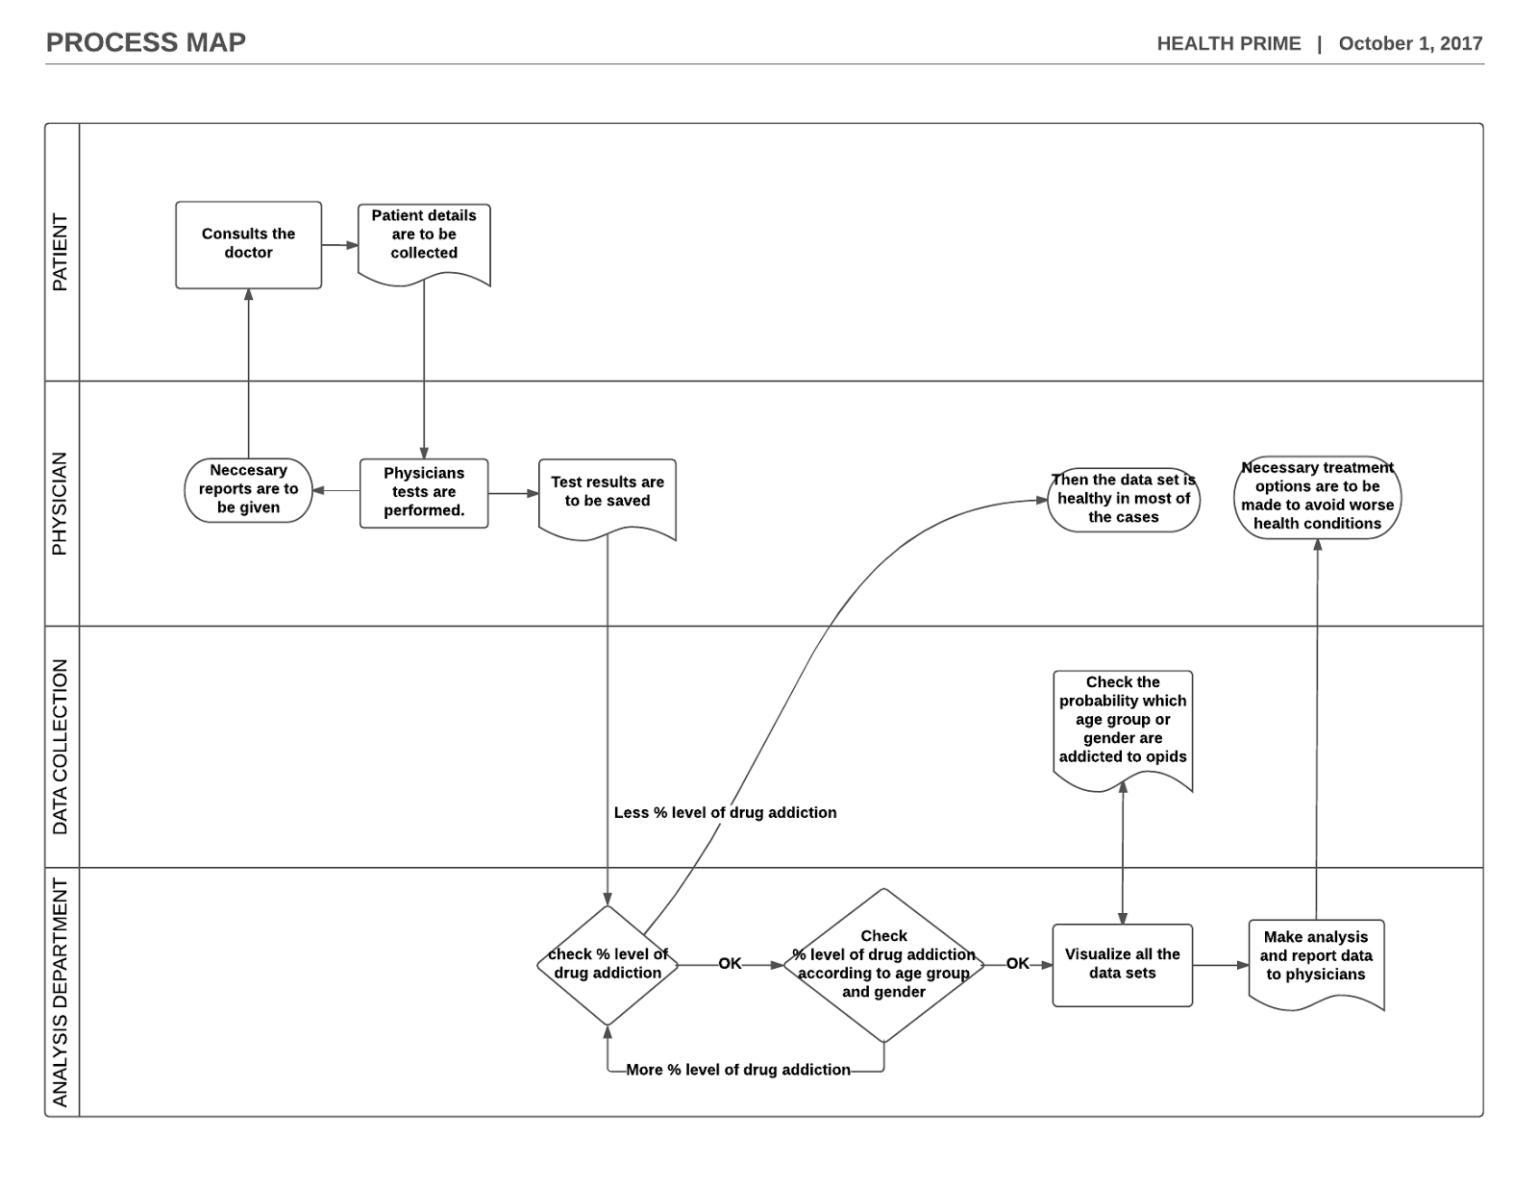

**Mitigation of Deployment Risks**

With any new endeavor there are always risks associated with it. There are however ways to mitigate those risks which we will discuss here. We recommend that any approach you take involve incremental implementation. We suggest you focus the ETL to one group within your organization, measure, test, correct and then start to expand to adding other group’s data. This will make it easier for you to troubleshoot things such as erroneous data and not propagate the problems to others groups thus making the issue larger for your IT folks to handle.

# **Change Management for Your Process Improvement**

We understand that change can be difficult and that part of the fear stems from how the change will impact your business operations. This is where a Change Management Plan (CMP) can be an effective tool to help you through your process improvement program. A CMP requires there are procedures and standardized methods in place to ensure that the change while minimizing impacts to the organization. A list of some of the possible things you could implement in your CMP follow:

* Develop a Request for Change
* Prepare a Cost/Benefit Analysis for the Change
* Change Testing
* Establish a Change Advisory Board
* Report Results
* Link Problems to Changes
* Audit the CMP

# **Integration of Dashboard with Legacy Systems**

The legacy systems that you have in place have worked for you on many levels. You have become accustomed to how they operate and provide feedback. There is no need to scrap the legacy systems all together in order to implement business intelligence. Certain methodologies can be adopted to integrate legacy systems with your new robust business intelligence solutions. For instance, through ETL, the data warehouse can pull information from your current databases. The ETL process does involve more resources to implement, so at some point it may be more cost effective to migrate your databases into a more cohesive software solution. Also you indicated that you would like to be able to work seamlessly with your new satellite office so this may be the time to think about cloud solutions as well, even though they can be more expensive upfront. Health Prime can work with you to develop a transition timeline that works within your budget and won’t impact your operations. Seamless and interoperable strategies have to be included for integration of the new systems without losing data from or affecting core functionalities performed by the legacy system.

**Dashboard Usability and Effectiveness**

We pulled data from a variety of internet sources to provide you with a few dashboard examples to give you a feel for Tableau and the power of BI. The data tells us about the opioid usage and its statistics in different locations and hospitals and how people are being affected by drugs from the past 10 years.

This dashboard is named as Statistics on opioid usage and we have used map filter so that it would help users to understand clearly about opioid usage based on the location. The dashboard explains about detox analysis, hospital locations and treatment analysis. According to our process this BI solution would help an organization to pull this data and make decisions that would help treating people suffering from drug usage. On the first detox analysis sheet we have used we have used data on detox so that the procedures from that particular hospital can be helpful.

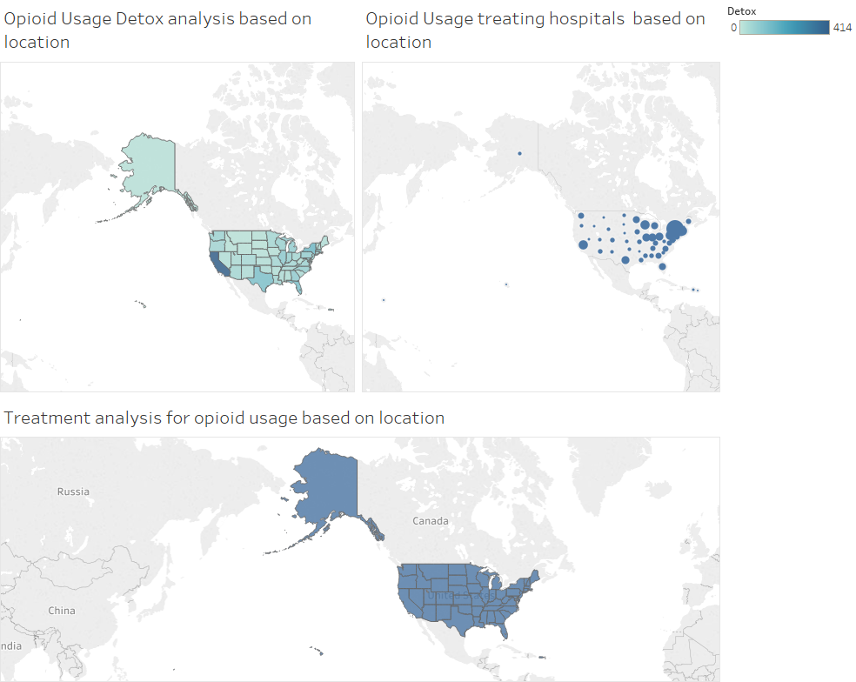

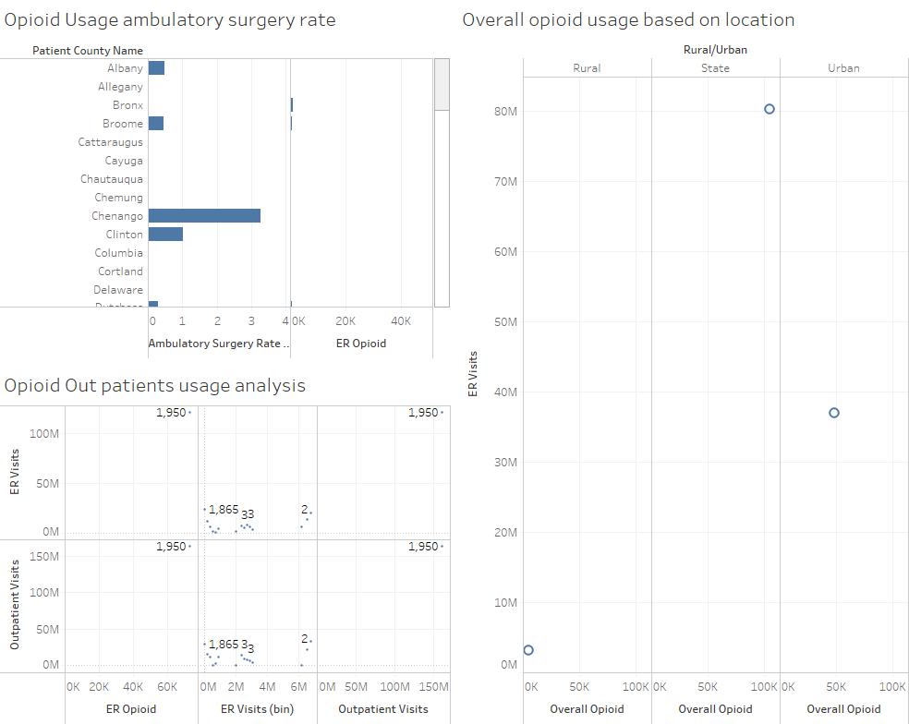

The dashboard is named as analysis on opioid usage on patient records. We have used 3 different kinds of visualizations, filters and aggregations successfully. Often data analysts try to include too much information into one dashboard. Having too much content typically leads to confusion.

In these dashboards data cleaning had a crucial importance.

The dashboard is named as analysis on opioid usage deaths based on age/ gender/ race. In this dashboard, we took different colors, factors into consideration so that it would be helpful to understand data clearly.

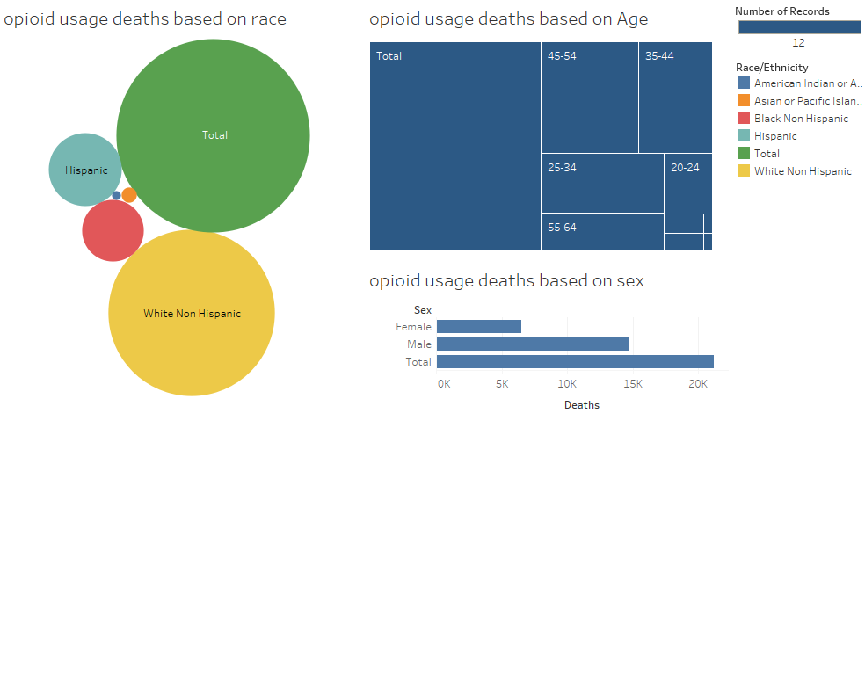

The dashboards are helpful in providing insights and allowing users to have stronger insights around the data. I believe this dashboard would help provide better insights about opioid usage and treatments for it and also allows the user to filter across multiple worksheets, and it uses color, size and shape effectively. Ultimately the dashboard doesn't answer "any question that someone may have" but rather directs them in their understanding and thought process. The data used had various options for performing analysis and can be helpful in future to make decisions to lower the drug rate and the third dashboard had analysis about opioid usage deaths it can be helpful in making predictive analytics solutions and avoid drug usage.

# **Resources (All)**

The data used in Tableau has been taken from Sandstone Care’s website and various sources on the internet.

[www.sandstonecare.com](http://www.sandstonecare.com)

<https://www.drugabuse.gov/drugs-abuse/opioids>

[www.google.com](http://www.google.com)

[www.idashboards.com](http://www.idashboards.com)